**Practical Work Experience and Portfolio Building**

**Evidence Reporting Document**

* **Introduction**

*The main goal of this document is to keep track of the practical hands-on work experience and lab challenges you will complete throughout the program. By doing so, at the end of the program, you will have a great portfolio that you can use for evidence of your practical skills, and you can also come back for review whenever needed. This evidence is essential in the long run and keeps you on track with the time you will spend on your career upgrade process. These notes will also play a vital role in identifying the skills and tools to reflect on your marketing materials like your CV/resume or LinkedIn Page.*

* **General Details**

**Date: 17 May 2024**

**Your Name: LOK HIM TAM (Himson)**

**Email-address:** himsom0528@gmail.com

**Name of the Challenge: Configure Azure Role Based Access Control [Guided]**

**Access Details (URL or source):** AZ500

**Details of the Challenge:**

In this lab I have working following exercise:

* Assigned an Azure built-in role to a user.
  + Assign the **Network Contributor** built-in role to a user named **Dev1-41229435@cloudslice.onmicrosoft.com** to allow the user to manage networks in the **AZ900RGlod41229435** resource group.
* Tested an Azure built-in role assignment.
  + Create an Azure virtual network (VNet)

There are three main components of a [VNet](https://docs.microsoft.com/en-us/azure/virtual-network/virtual-networks-overview" \t "_blank) that you must plan and implement:

* A [virtual network](https://azure.microsoft.com/en-us/services/virtual-network/) is a container that holds other networking components and configurations.
* A [virtual address space](https://docs.microsoft.com/en-us/windows/win32/memory/virtual-address-space) is a block of IP addresses that can be further divided into subnets. A VNet requires at least one virtual address space. The address spaces inside a VNet do not have to be contiguous.
* A [subnet](https://support.microsoft.com/en-us/help/164015/understanding-tcp-ip-addressing-and-subnetting-basics) is a block of IP addresses that are part of an address space. A VNet requires at least one subnet. The subnet must be part or all of the virtual address space in which it is created.
  + Create a storage account

Microsoft Azure Storage is a cloud service that provides access to storage from anywhere in the world while delivering security and redundancy. Azure Storage uses the following services:

* Azure Blobs (unstructured data)
* Azure Files (fully managed cloud-based file shares)
* Azure Queues (messages)
* Azure Tables (NoSQL data storage)

[General-purpose v2 storage accounts](https://docs.microsoft.com/en-us/azure/storage/common/storage-account-options) provide support for the latest storage service features such as access tiers.

Storage account names must be globally unique. They must be between 3 and 24 characters and can only contain numbers and lowercase letters. Special characters are not permitted.

Azure replicates data in [Azure storage accounts](https://docs.microsoft.com/en-us/azure/storage/common/storage-redundancy) so that durability and availability are maintained. The replication options that are available depend on the performance tier.

There are three [storage tiers](https://docs.microsoft.com/en-us/azure/storage/blobs/storage-blob-storage-tiers) available for Azure storage accounts: hot, cool, and archive. By selecting the right access tier for your needs, you can store your data in the most cost-effective manner. For example, the hot tier is the least expensive tier when accessing data, but it costs more to store the data. Conversely, the archive tier is optimized for data that is accessed infrequently. The archive tier is the most cost-effective option for storing data. However, accessing that data is more expensive than in the hot or cool tiers. The archive tier is only available for individual block blobs.

* Created a custom role.
  + Configure an Azure Cloud Shell **PowerShell**
  + [Azure Cloud Shell](https://docs.microsoft.com/en-us/azure/cloud-shell/overview) is a shell for managing Azure resources that you can [access](https://docs.microsoft.com/en-us/azure/cloud-shell/quickstart-powershell) on the Azure portal toolbar or by entering https://shell.azure.com in a browser. It allows you to work unhampered, without constantly presenting credentials, because you are already signed in to the Azure portal.
  + Azure Cloud Shell can interpret both [Azure PowerShell](https://docs.microsoft.com/en-us/powershell/azure/?view=azps-3.7.0) and Bash commands to create, update, and delete resources in the Azure portal. You can choose the commands you are most comfortable with, and you do not need to install any extra components. Azure Cloud Shell allows you to make calls to files that you upload to Azure—for example, .JSON files—to provide interactivity between Azure Cloud Shell, the Azure portal, and [Azure Resource Manager templates](https://docs.microsoft.com/en-us/azure/azure-resource-manager/templates/template-syntax).
  + The first time you use Azure Cloud Shell, you will configure a storage account that will be used to log all pertinent information from the shell. Azure Cloud Shell requires a storage account and a file share to store commands and scripts. Storage account and file share names must be all lowercase.
* Identify the operations associated with virtual machines by using the Azure PowerShell [Get-AzProviderOperation](https://docs.microsoft.com/en-us/powershell/module/az.resources/get-azprovideroperation?view=azps-3.7.0) cmdlet.
  + - Get-AzProviderOperation "Microsoft.Compute/virtualmachines/\*" | FT Operation, Description -AutoSize
* Retrieve the role definition for the built-in Virtual Machine Contributor role and output it to $home\clouddrive\VMOperatorRole.json by using the Azure PowerShell [Get-AzRoleDefinition](https://docs.microsoft.com/en-us/powershell/module/az.resources/get-azroledefinition?view=azps-3.7.0) cmdlet.
  + Get-AzRoleDefinition -Name "Virtual Machine Contributor" | ConvertTo-Json | Out-File $home\clouddrive\VMOperatorRole.json
* Open the VMOperatorRole.json file in the Azure Cloud Shell code editor by using the code command in the $home\clouddrive directory.
* Edit the **VMOperatorRole.json** file to change the **Name** property value to Virtual Machine Operator, delete the line that contains the **Id** property, change the **IsCustom** value to true, and then change the **Description** value to "Lets you view, start, and stop virtual machines."
* Edit the **VMOperatorRole.json** file to contain only the "Microsoft.Compute/\*/read", "Microsoft.Compute/virtualMachines/start/action", and "Microsoft.Compute/virtualMachines/deallocate/action" actions.
* 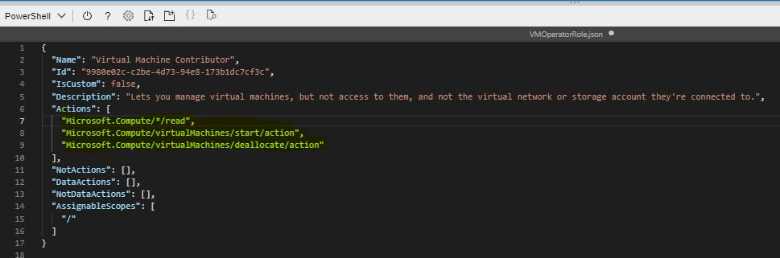
* Create a new custom role by using the Azure PowerShell [New-AzRoleDefinition](https://docs.microsoft.com/en-us/powershell/module/az.resources/new-azroledefinition?view=azps-3.7.0) cmdlet and the VMOperatorRole.json file.
  + New-AzRoleDefinition -InputFile "$home\clouddrive\VMOperatorRole.json"

**Lab Topology**

Create an Azure virtual network (VNet) by using the values in the following table:

| **Property** | **Value** |
| --- | --- |
| Resource group | **AZ900RGlod41229435** |
| Name | VNet1 |
| Region | **(US) East US 2** |
| IPv4 address space | 10.0.0.0/16 |
| Subnet name | Production |
| Subnet address range | 10.0.0.0/24 |

* **Challenge Details**

**Before starting the challenge:**

1. Be sure that the lab is in the scope of your niche.
2. You have enough time to solve the full lab or have a proper plan to solve a part of it and complete the remaining sections later.
3. Try to build a good learning environment with less distraction for at least 30 minutes to an hour.

**After completing the challenge:**

1. Were you able to finish the lab? Did you need extra time? Was the lab relevant to your expectations? Did you need additional help to solve the lab?

* Yes I am able to finish the lab within 45 mins. It is relevant to my expectations. And I can finish it without additional help.

1. Write down your learning outcomes, skills you developed or improved and the tools you used in this challenge.

*(You may use the keywords listed in the lab details or add your own skills that you think you acquired.)*

* I have learnt how to assigned an Azure built-in role to a user as **Network Contributor** built-in role.
* I have learnt how to tested an Azure built-in role assignment by creating an Azure virtual network (VNet)
* I have learnt three main components of VNet, virtual network, virtual address space and subnet
* I have learnt how to create a custom role by using Azure Cloud Shell **PowerShell.**
  + I have learnt more about cloud shell and how to configure them.
  + I have learnt how to config a new customer azure role by using cmdlet in powershell

1. Prepare a self-reflection and reporting video using any screen recording tool (like Loom) and share the link.

*(The report may include but is not limited to your thoughts about the problem solved, difficulties encountered, any notes to discuss with your peers, anything to ask the mentors and last but not least how it may help you in your ideal job. Please prepare the summary in a way that you are presenting this to your managers and colleagues in your ideal workplace)*

**URL:**

[**https://www.loom.com/share/f5fcd152eda840d3879f128603c43d85?sid=f477a789-9fea-4692-97a6-4f4e9920cf33**](https://www.loom.com/share/f5fcd152eda840d3879f128603c43d85?sid=f477a789-9fea-4692-97a6-4f4e9920cf33)